***Driver drowsiness detection system using Deep neural network techniques***

G.Dhamodhar Department of Computer Science and Engineering Kalasalingam Academy of Research and Education Virudhnagar, Tamilnadu, India [9920004369@klu.ac.in](mailto:9920004369@klu.ac.in)

A.Sameer reddy Department of Computer Science and Engineering Kalasalingam Academy of Research and Education Virudhnagar, Tamilnadu, India [9920004303@klu.ac.in](mailto:9920004303@klu.ac.in)

D.Sampath reddy Department of Computer Science and Engineering Kalasalingam Academy of Research and Education Virudhnagar, Tamilnadu, India [9920004324@klu.ac.in](mailto:9920004324@klu.ac.in)

B.Vamsi Krishna Department of Computer Science and Engineering Kalasalingam Academy of Research and Education Virudhnagar, Tamilnadu, India [9920004323@klu.ac.in](mailto:9920004323@klu.ac.in)

*Abstract: Nowadays Drowsiness is the main cause of road accidents due to less sleep or tiredness driver may fall asleep according to the National Highway Traffic Safety Administration 1 lakh vehicles per year are victimizing to accidents due to drowsiness so to reduce the of accidents happening due to drowsiness of driver we have implemented a system it will detect the drivers who are falling asleep and will sound an alarm with the use of speaker. The face detection and eye detection of the driver can be achieved by using open cv and Keras and we will classify that the eye(open or close) by using Cnn In deep learning, a CNN is a class of artificial neural network, most commonly applied to analyze visual images*

Keywords: Open cv, Keras, deep neural network, convolutional neural network

# Introduction (*Heading 1*)

According to the statistics the higher officials are saying that drowsiness of drivers is one of the most important factors in road accidents, and it is close to more than 2 times higher than other causes of traffic accidents. As a solution to resolve these problems, it is possible to reduce accidents by detecting and preventing drivers from drowsiness while driving. Therefore, we aimed at detecting and preventing this kind of road accident. In this study, a device for preventing drowsy driving was selected, and we have surveyed a lot of members who drive a lot. The survey consisted of a number of questions related to car driving and, driving habits related to driving drowsily, the surroundings of the vehicle, and driving drowsily in order to gain perceptions to improve our ideas. The survey was conducted with about 200 people. To reduce accidents due to this Drowsiness we have developed this system in this we have used Opencv and Keras these are the libraries used for the detection of face and eye. These packages focus on the image, video processing, and analysis in the face and object detection features. Facial recognition is considered a difficult problem in computer vision research. Human eyes play a significant role in facial recognition and facial expression analysis. Human eyes are a stable feature compared with other facial features. Therefore, in recognizing facial features, it is advantageous to recognize the eyes. Using the eye position we can estimate the location of certain facial features. So by the classification of an eye whether it is opened or not we will detect the tiredness or drowsiness of the driver. The software required for this project is Python, Windows OS, OpenCV, Keras, Tensorflow .

🡪Workflow of the system

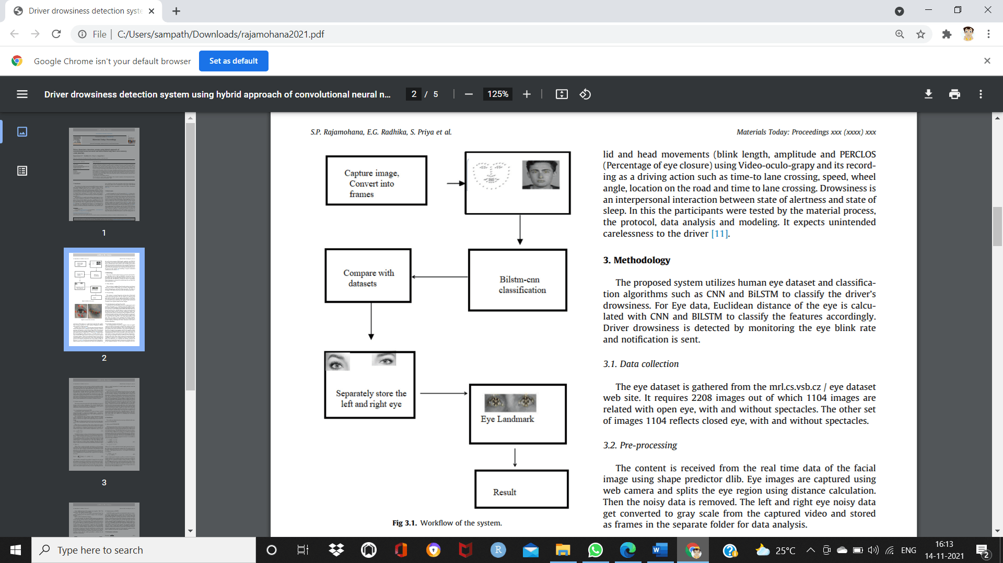

# LITERATURE REVIEW

Our main concentration for the literature survey was a literature that addresses the problem report and to research about growths on the same. Hence, our primary emphasis was based on three measures to detect drowsiness - Physiological Measures, Behavioural Measures, and Vehicle-based Measures. In this paper, we have proposed a system that uses Behavioural Measures to detect drowsiness, we have trained the system/model, and finally, provide positive results. It provided correct and satisfying results as it was more highlighted towards the features of drowsiness of person. Focusing on features such as closing eyes repeatedly, keeping eyes closed for a longer time, yawning, moving the head more than usual, etc. assisted in providing better results. It has a comparative study of all three measures. These methods have been studied in point and the advantages and disadvantages of each have been discussed. To develop an efficient drowsiness detection system, the assets of the various measures should be combined into a hybrid system which is a combination of two or more measures. However, it has not been implemented in real-time so we didn’t consider working on a hybrid model.. Most experiments using behavioral measures are conducted in a simulated environment and the results indicate that it is a reliable method to detect drowsiness. So far various methods have been implemented in the works of drowsiness detection using behavioral measures. Out of which CNN assurances the highest accuracy which is close to 100.

🡪MEASURES TO DETECT DROWSINESS

|  |  |  |  |
| --- | --- | --- | --- |
| Measures | Constraints | Advantages | Disadvantages |
| Behavioral | Deviation from the lane  position loss of control  over the steering wheel  movements | Non-intrusive | Undependable |
| Physiological | Statistical & energy | Non-intrusive,  ease of use | Lightning condition  related |
| Physiological | Stress |  | Indiscreet |

Franklin and Eddie Galarza projected a drowsiness detection system based on a driver’s face image using a system of Human-Computer Interaction executed on a Smartphone. If it detects that the person is drowsy, then it will alarm the driver and wake him up with the same smartphone. The system used the perclos algorithm for eye detection and with an accuracy of 98.7% for the blink rate. The objective of this work was to implement a surveillance system that alarms the driver. We decided to use this feature in our proposed system to alert the driver The template is used to format your paper and style the text. All margins, column widths, line spaces, and text fonts are prescribed; please do not alter them. You may note peculiarities. For example, the head margin in this template measures proportionately more than is customary. This measurement and others are deliberate, using specifications that anticipate your paper as one part of the entire proceedings, and not as an independent document. Please do not revise any of the current designations.

# MODELING

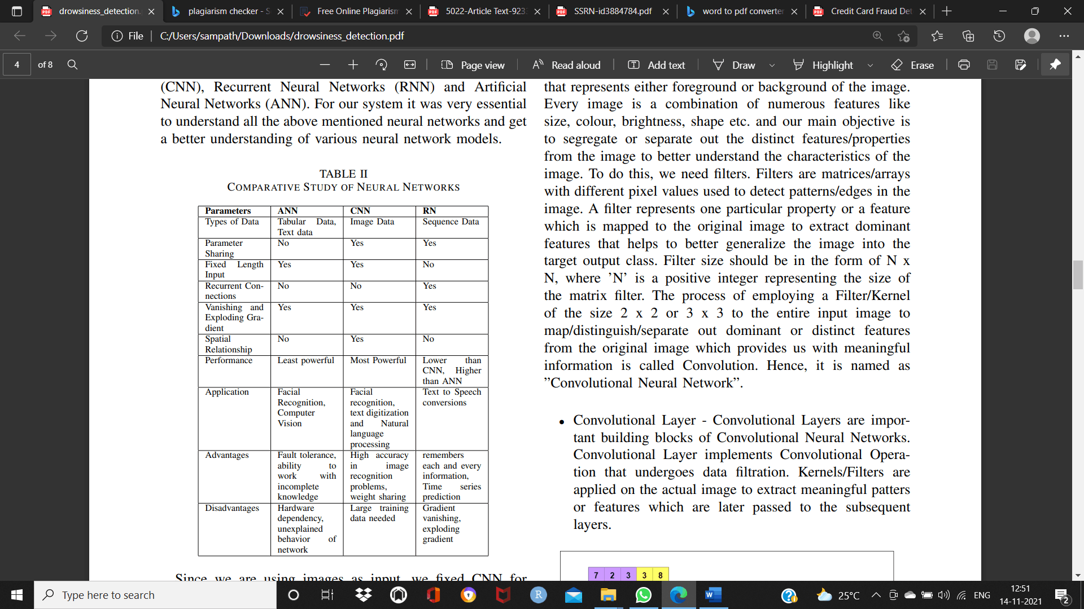

🡪The architectural design of open cv

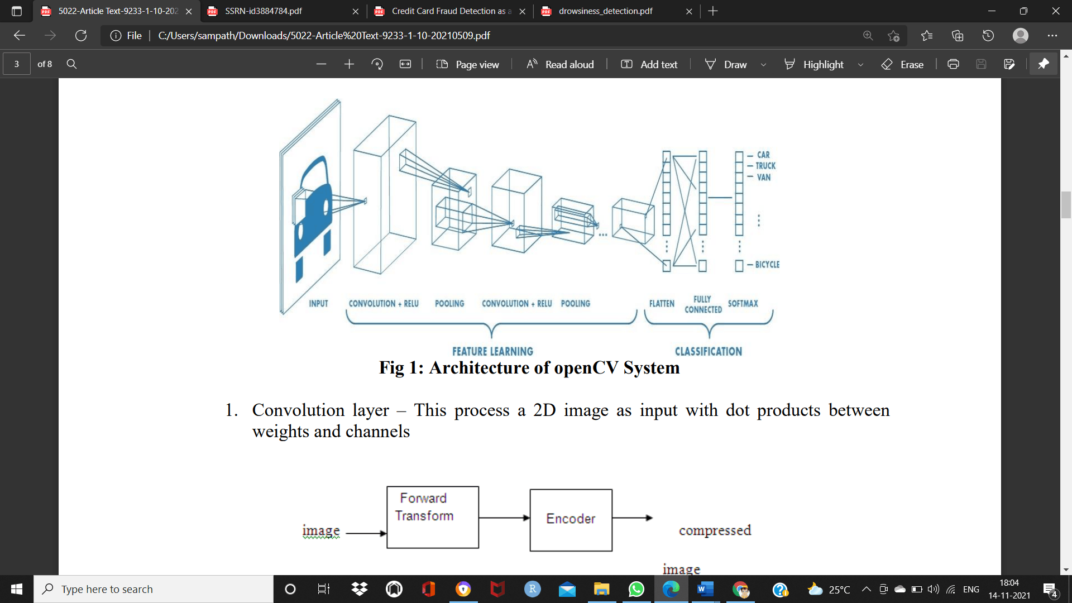

A Convolutional Neural Network (ConvNet/CNN) is a Deep Learning algorithm that takes images as input, assigns importance (learnable weights and biases) to various aspects/objects in the image, and is able to differentiate/classify data in various categories/classes. The pre-processing required in a ConvNet is much lower as compared to other classification algorithms, while in primitive methods filters are hand-engineered with enough training, ConvNets have the ability to learn these filters/characteristics. A Convolutional Neural Network typically consists of Convolutional Layers which undergo recurrent downsampling by applying pooling layers. Pooling Layers are responsible for extracting dominant features from obtained input data and transmitting its output to the subsequent layers like normalization layers and fully connected layers.

CNN is majorly used for processing image data and for image classification. With the help of CNN, you can easily build a classification model. An image is nothing but a matrix with several pixel values that represent various features like brightness, shape, size, color, etc. A pixel is a 1-bit number that represents either foreground or background of the image. Every image is a combination of numerous features like size, color, brightness, shape, etc. and our main objective is to segregate or separate the distinct features/properties from the image to better understand the characteristics of the image. To do this, we need filters. Filters are matrices/arrays with different pixel values used to detect patterns/edges in the image. A filter represents one particular property or a feature that is mapped to the original image to extract dominant features that helps to better generalize the image into the target output class. Filter size should be in the form of N x N, where ’N’ is a positive integer representing the size of the matrix filter. The process of employing a Filter/Kernel of the size 2 x 2 or 3 x 3 to the entire input image to map/distinguish/separate dominant or distinct features from the original image which provides us with meaningful information is called Convolution. Hence, it is named as ”Convolutional Neural Network”.

Convolutional Layer implements Convolutional Operation that undergoes data filtration. Kernels/Filters are applied to the actual image to extract useful patterns or features that are later passed to the concurrent layers

🡪Convolution layer

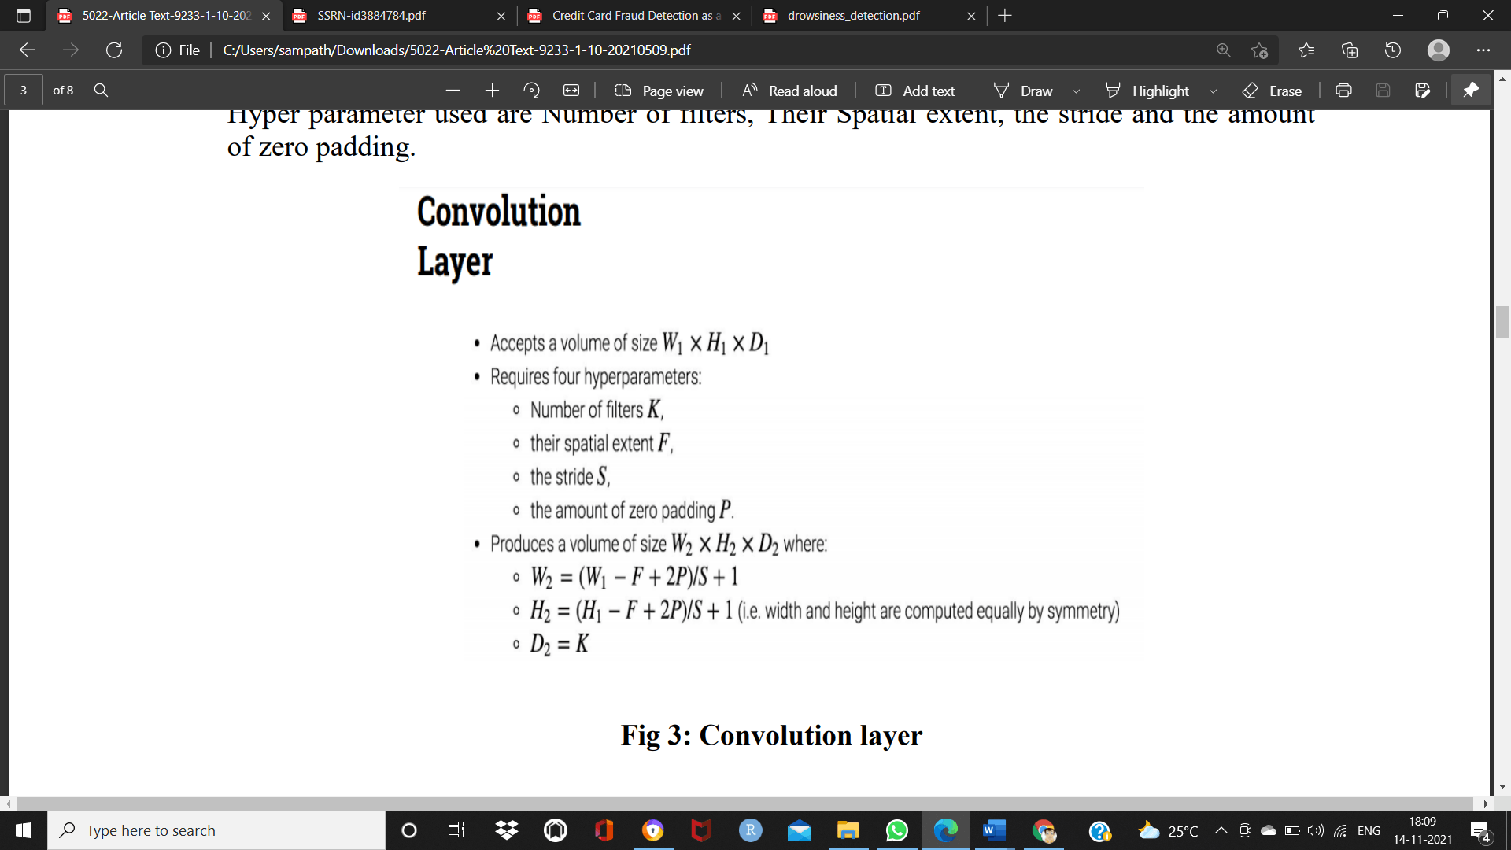

## IV. PERFORMANCE EVALUATION

Identify applicable sponsor/s here. If no sponsors, delete this text box (*sponsors).*

Precision = TP/TP+FP

A recall is the percentage of all properly listed categories. This evaluates the effectiveness of the specific framework that is used in classification. The recall is given in eqn

Recall = TP/TP+FN

Accuracy is calculated as the ratio of true positive and true negative to the overall measures. The equation gives the accuracy formula.

Accuracy = TP+TN/TP+TN+FP+FN

F1 Score is calculated as the ratio of the weighted average of precision and Recall to twice the combination of Precision and Recall. The equation gives the F1 Score formula

F1Score= 2 + (Recall + Precision)/ Recall + Precision

🡪Pre-processed Result of CLOSED EYE

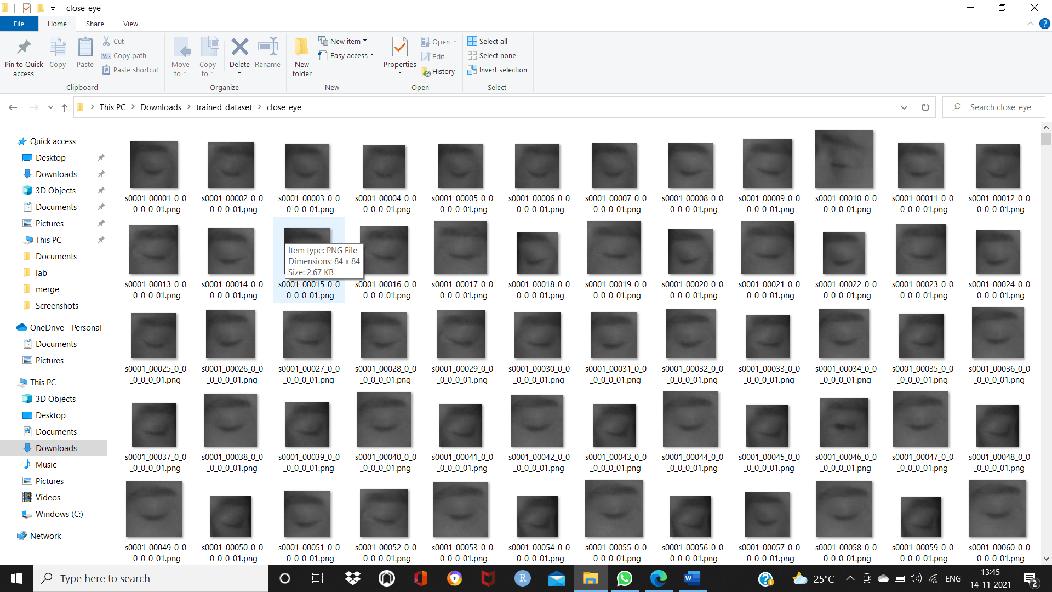

🡪Pre-processed Result of OPEN EYE

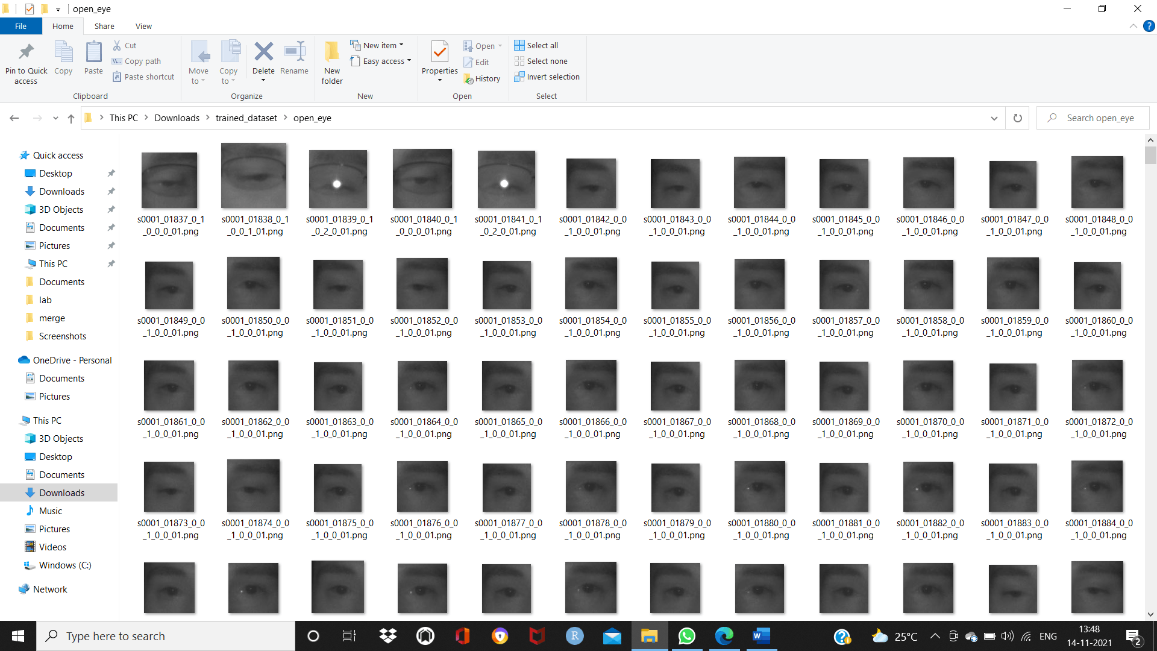

# V. RESULTS AND DISCUSSION

The results for several conditions were calculated and tested to achieve high accuracy. These conditions vary from person to person, with a person under observation having their eyes closed or open. The person could be someone who wears spectacles due to which might cause reflection of light and result in a glared image, making it difficult for feature extraction and feature selection. So, to avoid these hindrances, the proposed model was tested against the above-mentioned constraints as well to achieve satisfactory results. Various conditions with their corresponding results have been depicted in the figures below

🡪SCREENSHOTS

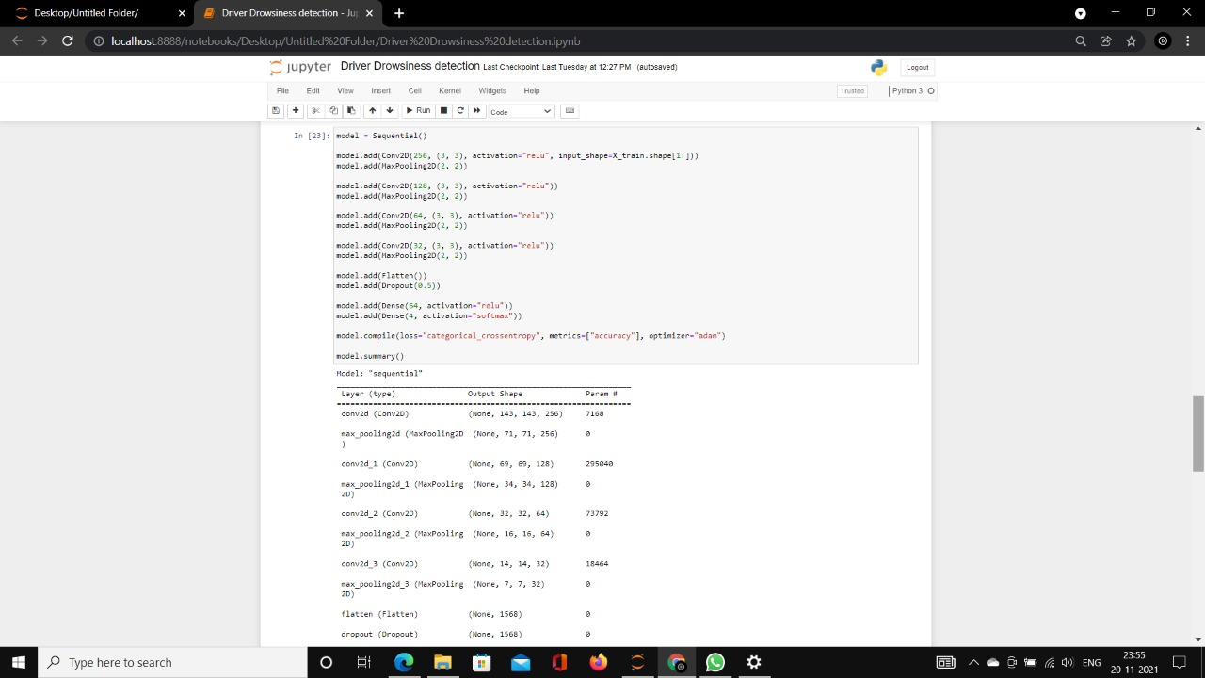

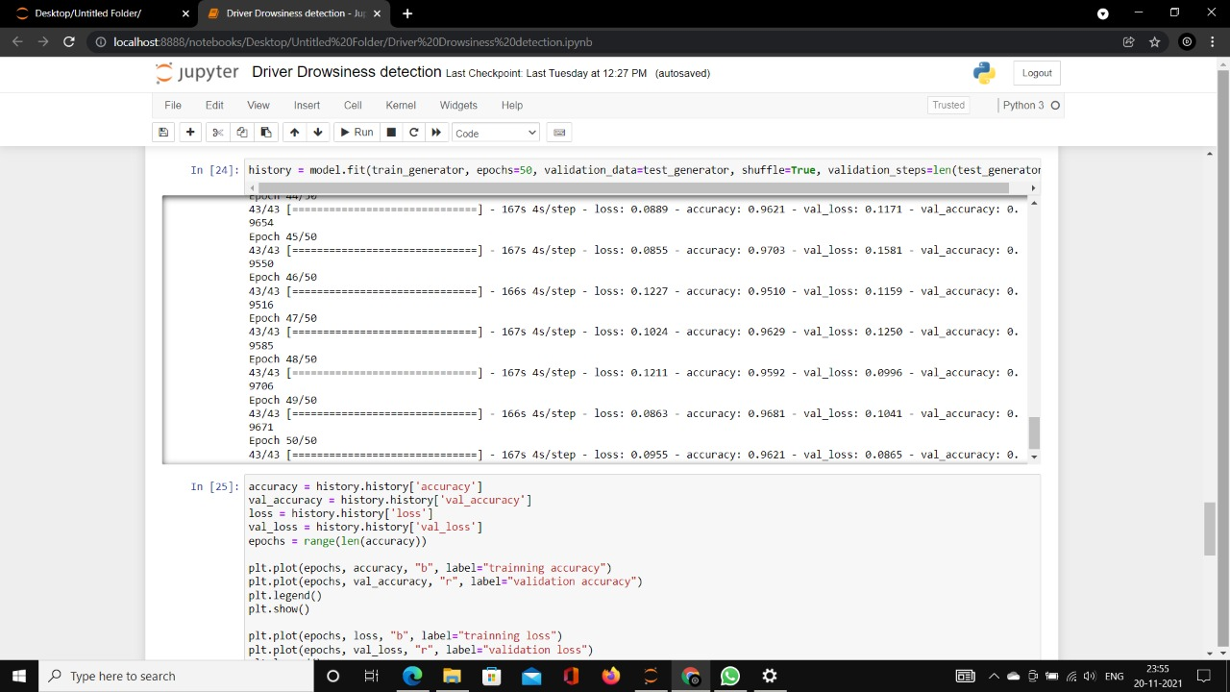

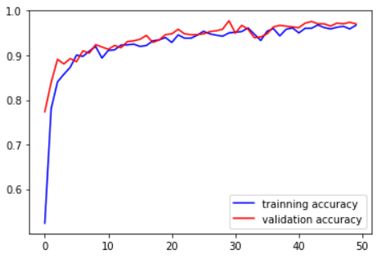

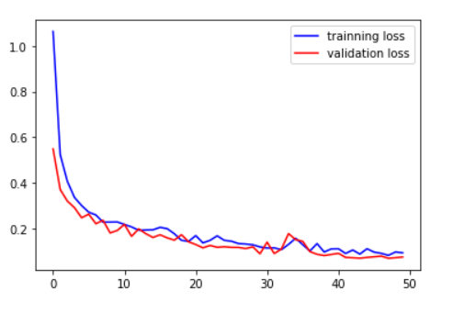

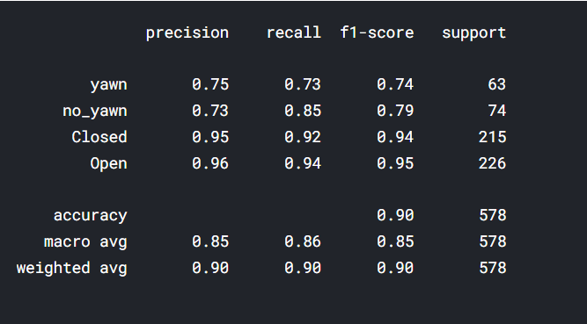

VI. CONCLUSION

Using this Open CV system it will be easy for mounting inside the car several sensors together with the processing and alarm device. With the advent of science and technology in every walk of life, the importance of vehicle safety has increased, and the main priority is being given to reducing the alarming time when an accident occurs so that the wounded lives can be attended in lesser time by the rescue team, and we can also avoid accidents by providing alerts systems that can stop the vehicle to overcome the accidents. The driver alert mode is adjustable to the user’s needs, can go from silent and only visual but it can be also loud.

VII. ACKNOWLEDGMENT

We would like to extend our sincere gratitude towards

our Project Guide, R.Sumathi for guiding and mentoring us

throughout the course of project development and

implementation, providing us with the necessary resources,

knowledge and constant moral support.

VIII. REFERENCES

[1] Vishnu, R., et al. "Driver drowsiness detection system with OpenCV and Keras." *Journal of Physics: Conference Series*. Vol. 1916. No. 1. IOP Publishing, 2021.

[2] Kaushish, Vedant, et al. "Driver Drowsiness Detection System with OpenCV and Keras." Available at SSRN 3884784 (2021).

[3] Saranya, L., et al. "Drowsiness Detection and Alert System Using Open Cv." Annals of the Romanian Society for Cell Biology (2021): 3608-3615

[4] Rajamohana, S. P., et al. "Driver drowsiness detection system using hybrid approach of convolutional neural network and bidirectional long short term memory (CNN_BILSTM)." Materials Today: Proceedings 45 (2021): 2897-2901.